*Faces Pain Scale – Revised (FPS-R):
https://www.iasp-pain.org/files/Content/ContentFolders/Resources2/FPSR/facepainscale_english_eng-au-ca.pdf
In the following instructions, say "hurt" or "pain", whichever seems right for a child.
"These faces show how much something can hurt. This face [point to face on far left] shows no pain. The faces show more and more pain [point to each from left to right] up to this one [point to face on far right] - it shows very much pain. Point to the face that shows how much you hurt [right now]."
Score the chosen face 0, 2, 4, 6, 8, or 10, counting left to right, so “0” = “no pain” and “10” = “very much pain”. Do not use words like “happy” or “sad”. This scale is intended to measure how children feel inside, not how their face looks.
Permission for Use. Copyright of the FPS-R is held by the International Association for the Study of Pain (IASP) ©2001. This material may be photocopied for non-commercial clinical, educational and research use. For reproduction of the FPS-R in a journal, book or web page, or for any commercial use of the scale, request permission from IASP online at www.iasp-pain.org/FPS-R.
Sources. Hicks CL, von Baeyer CL, Spafford P, van Korlaar I, Goodenough B. The Faces Pain Scale – Revised: Toward a common metric in pediatric pain measurement. Pain 2001;93:173-183. Bieri D, Reeve R, Champion GD, Addicoat L, Ziegler J. The Faces Pain Scale for the self-assessment of the severity of pain experienced by children: Development, initial validation and preliminary investigation for ratio scale properties. Pain 1990;41:139-150.
(fold
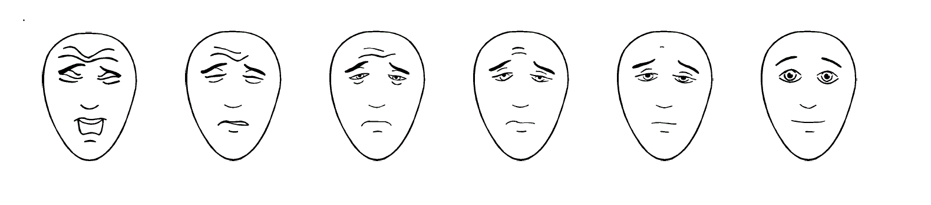

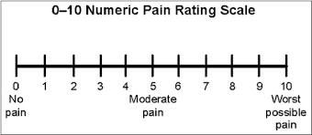
0–10 Numeric Pain Rating Scale:

Explanation:
- For use with ages 8 and older
- Explain to the child that at one end of the line is 0, which means that a person feels no pain (hurt). At the other end is a 10, which means the person feels the worst pain imaginable. The numbers 1 to 9 are for a very little pain to a whole lot. Ask the child to choose the number that best describes how he/she is feeling.

0=no pain 1–3=mild pain 4=moderate pain 7–10=severe pain

Visual Analog Scale (0-10):
Mark ’X’ to area on the line with 0 being no pain to 10 being the worst pain.

0 10

Paired Tender Points:
Cervical Vertebrae Right Left
Trapezius Right Left
Second Rib Right Left
Lateral Epicondyle Right Left
Knees Right Left
Occiput Right Left
Supraspinatus Right Left
Gluteal Muscles Right Left
Trochanter Major Right Left

*Has fibromyalgia been diagnosed?
Yes
No
Unknown

*If yes, how was it assessed?
1990 criterion¹
2010 criterion²
2016 criterion³
Other, specify

GENERAL INSTRUCTIONS
Important note: The data element noted with a single asterisk on this CRF Module is classified as Supplemental-Highly Recommended (i.e., strongly recommended for ME/CFS Pediatric Pain clinical studies to collect). All other data elements are classified as supplemental (i.e., non Core) and should only be collected if the research team considers them appropriate for their study.
* Data element is Supplemental-Highly Recommended.

All other data elements are supplemental.

SPECIFIC INSTRUCTIONS
Please see the Data Dictionary for definitions for each of the data elements included in this CRF Module.

References
  - Wolfe F, et al. The American College of Rheumatology 1990 Criteria for the Classification of Fibromyalgia: Report of the Multicenter Criteria Committee. Arthritis Rheum. 1990;33(2):160–172.
  - Wolf F, et al. The American College of Rheumatology preliminary diagnostic criteria for fibromyalgia and measurement of symptom severity. Arthritis Care Res. 2010;62(5):600–610.
  - Wolfe F, et al. 2016 Revisions to the 2010/2011 fibromyalgia diagnostic criteria. Semin Arthritis Rheum. 2016;46(3):319-329.

