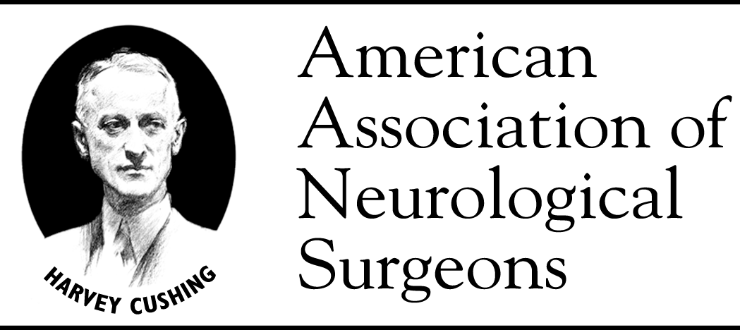

American Association of Neurological Surgeons

# June 13, 2013

Joanne Odenkirchen, M.P.H.

Clinical Research Project Manager, Division of Extramural Research

NIH/NINDS

Neuroscience Center, Room 2178

6001 Executive Blvd MSC 9520

Bethesda, MD 20892-9520

Re: Common Data Elements for Traumatic Brain Injury, Version 2.0

Dear Ms. Odenkirchen:

On behalf of the American Association of Neurological Surgeons, representing 4,000 neurosurgeons in the United States, we would like to thank you for your ongoing efforts to develop version 2.0 of the Common Data Elements for Traumatic Brain Injury (TBI), which have been revised and reorganized since our previous endorsement of the initial version in 2009. Because NINDS funds a great deal of government-supported TBI research in this country, we commend you for the foresight to update and improve this crucial project.

TBI is a complex injury with a broad spectrum of symptoms and disabilities and a devastating impact on a person and his or her family. This project will minimize the investigator's need to design new case report forms and collection instruments every time a new TBI study or trial is funded. The common sets of data collection instruments and variables are applicable to studies of epidemiology, acute care, rehabilitation, and mild TBI and concussion, and encompass prehospital (demographic), emergency department, imaging, biomarker/laboratory, surgical, ICU, acute care hospital, rehabilitation, and short- and long-term outcome data points. Additional consideration has been made for studies involving pediatric, military, and sports-related TBI.

As you are aware, another advantage of this approach is that the data from these standardized collection instruments can be deposited into a large database that grows every time a new study is added. The IMPACT database project was extremely labor-intensive and took years to standardize data from about a dozen TBI trials into one large database. Use of the Common Data Element approach will virtually eliminate this problem in the future.

Again, we would like to thank you for your efforts and offer our full support for this project.

Yours truly,

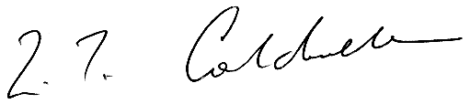

William Couldwell, MD, PhD

President, American Association of Neurological Surgeons

cc: Ramona Hicks, PhD

Joseph Giacino, PhD

Cindy Harrison-Felix, PhD

## 5550 Meadowbrook Drive

## Rolling Meadows, IL 60008

**member services:** 888.566.AANS

**phone:** 847.378.0500

**fax:** 847.378.0600

**web:** [www.AANS.org](http://www.AANS.org)

**2013-2014 Board of Directors**

**President**

William T. Couldwell [william.couldwell@hsc.utah.edu](mailto:william.couldwell@hsc.utah.edu)

**President-Elect**

Robert E. Harbaugh

[rharbaugh@psu.edu](mailto:rharbaugh@psu.edu)

**Vice-President**

Gary M. Bloomgarden

gbloomgarden@gmail.com

**Secretary**

Frederick A. Boop

[faboop@aol.com](mailto:faboop@aol.com)

**Treasurer**

Alex B. Valadka

[avaladka@gmail.com](mailto:avaladka@gmail.com)

**Past President**

Mitchel S. Berger

[bergerm@neurosurg.ucsf.edu](mailto:bergerm@neurosurg.ucsf.edu)

**Directors-at-Large**

Anthony L. Asher

H. Hunt Batjer

Deborah L. Benzil

E. Sander Connolly, Jr.

Christopher I. Shaffrey

Shelly D. Timmons

**Regional Directors**

NE: N. Ross Jenkins

NW: Monica C. Wehby

SE: John D. Davis

SW: J. Adair Prall

**Historian**

Samuel H. Greenblatt

**Executive Director**

Thomas A. Marshall

[tam@aans.org](mailto:tam@aans.org)