GENERAL INFORMATION

OBJECTIVE
This document describes the requirements for the collection, processing, and shipment of saliva samples from research sites to a central storage site. Adherence to this protocol will ensure that all samples are stable and accounted for during the collection and transport process.

SCOPE
This protocol applies to all saliva samples collected during the course of the study as well as all staff responsible for collecting, processing, recording, and shipping such samples.

RESPONSIBILITIES
- All personnel involved in specimen handling will be trained and certified on the United States and International laws governing the handling and transport of blood-borne, bio-hazardous materials through their site’s recognized local agency(s).
- The Principal Investigator (PI) at each research site is responsible to ensure the proper handling of study samples.
- Each research site is responsible for organizing and documenting sample shipments to the central processing and storage facility.
- The central processing and storage facility is responsible for receiving and documenting sample shipments, storing samples from all centers, and transferring samples to other laboratories as requested.

ATTACHMENTS
  - Appendix 1: Biological Sample and Shipment Notification Form (CARE Consortium example)
  - Appendix 2: 10x PIC Preparation Schematic
  - Appendix 3: Saliva Collection and Aliquoting Schematic
  - Appendix 4: Summary of Shipping Information
  - Appendix 5: Shipping Labels (Example)
  - Appendix 6: Specimen Labels (Summary & Example)

SUPPLIES

SITE REQUIRED EQUIPMENT
The following materials and equipment are necessary for the processing of specimens at the collection site:
      - Personal Protective Equipment: lab coat, nitrile/latex gloves, and safety glasses
      - Microcentrifuge tube rack
      - Biohazard bin and lid
      - Centrifuge balance tube
      - Private Room for Collection

In order to process samples consistently across all projects and ensure the highest quality samples possible, sites must have access to the following equipment:
            - Centrifuge capable of 2000 g and reaching 4°C.
            - Centrifuge rotor capable of accommodating 15ml conical tubes
            - -20°C non-frost free freezer
            - -80°C non-frost free freezer

SPECIMEN COLLECTION & STORAGE SUPPLIES
- Plastic biohazard bag with absorbent sheet
- 1 x 50.0ml Conical Tube
- 1 x 15ml Conical Tube
- 10 x 2.0ml cryovials with clear cap for collection of saliva
- 10 x 2.0ml cryovials with clear cap for aliquoted PIC storage
- 25 cell cryobox per patient
- Bio-Pen for labeling the 50.0ml & 15 ml Conical Tubes and writing on Subject and Site ID Labels
- Labels: Kit Label
- Labels: Subject and Site ID Label
- Labels: Collection Tubes and Cryovials Label

SPECIMEN PROCESSING SUPPLIES
- 10X Protease Inhibitor Cocktail (prepared from 100x PIC; Sigma-Aldrich P8340-1ML)
- ddH₂0 for PIC preparation
- Serological pipette filler
- 10ml Serological pipette
- P1000 Pipette and P1000 micropipette tips (2 x 1.0ml disposable graduated transfer pipettes)
- Ice to chill sample storage tubes
- Container to hold Ice

PACKAGING SUPPLIES
- PRIMARY RECEPTACLE: Cryovial that holds biospecimen aliquots
- SECONDARY RECEPTACLE: Leak-proof, biohazard-labeled plastic bag, capable of withstanding pressures to 95kPa during air transport with absorbent sheet
  - OUTER SHIPPING PACKAGE: Insulated bio-shipment box
        - Example: a 16”x16”x16”inner styrofoam box placed inside a 17”x17”x17”outer cardboard box.
  - DRY ICE: Enough to fill styrofoam box entirely after samples are packed
a. For the example box described above: approximately 18-20 kg (40-45 lbs) is needed
  - CENTRAL FACILITY PROCESSING FORM: Place in separate plastic bag and include in shipment
  - COURIER LABEL: Individual site’s address entered in the “Sender” area and the central storage facility’s address in the recipient area
  - SHIPPING LABELS: Required to communicate the contents of the package to the courier
        - Fragile label
        - Exempt Human Specimen label
        - “This side up” arrow labels
        - Class 9 (dry ice) label

PIC PREPARATION

GENERAL PREPARATION INFORMATION
            - The site will need ddH₂O (sterile water) to prepare a 10X PIC reagent from 100x PIC for saliva samples.
              - This will prevent digestive enzymes in saliva from breaking down candidate biomarker proteins.
            - 10x Preparation should be completed prior to subject visit to minimize work during subject visit.
- BEFORE SUBJECT VISIT (upon receipt of PIC)
- Thaw 100x PIC at room temperature prior to aliquoting.
              - Avoid freeze/thaw cycles
- Using BioPen, label the 10 x 2ml cryovials: 100x PIC: DATE
- Aliquot 100 µl of 100x PIC solution into each labeled cryovial.
- Store 100x PIC aliquots at -20°C and minimize exposure to light.
- See Appendix 2 for detailed schematic which depicts PIC preparation.

- EARLIER ON DAY OF SUBJECT VISIT
- Remove single aliquot of 100x PIC and that at room temperature.
- Prepare 10x PIC by diluting 1:10 in a 2.0 ml cryovial.
  - Add 900 µl sterile ddH₂0 to 100 µl of 100x PIC.
- Invert 8-10 times to mix and keep it at room temperature until saliva sample processing.
- Label and pre-chill 50.0ml and 15.0ml conical tubes and 2.0ml cryovials.
  - Label all collection tubes with two labels: Subject ID label and Collection Tube/Cryovial Labels.
    - Write Subject ID and Site ID on Subject ID label for all conical tubes using Bio-pen and place label on container.
- Label all cryovials with the Collection Tube/Cryovial labels only.
    - Collection Tube/Cryovial Labels contain preprinted study name, sample type, specimen number, and kit number.
      - Specimen number uniquely identifies that specimen.
      - Kit number ties all samples collected from one subject at one visit together.
- Place all tubes on ice.

BIOSPECIMEN COLLECTION

GENERAL Collection INFORMATION
- Prepare kit prior to sample collection and follow Universal Precautions at all times.
- All collection tubes and cryovials should be labeled prior to collecting subject’s saliva.
  - See Appendix 6 for examples of all labels.
- Track the patient closely and obtain the saliva as soon as possible (within 24 hours of injury for acute sample).
- Prepare subject for collection.
  - Instruct subject to thoroughly rinse their mouth with water for 1 minute.
  - Escort subject to quiet, empty room.
    - Let subject rest for 5 minutes.
  - Hand subject the chilled 50.0ml conical tube.
  - Instruct subject to lean forward and hold their head down over the collection tube.
    - Do not use induction techniques such as sugar.
    - Subject should not spit saliva into conical tube.
  - Saliva will accumulate in their mouth and will come out by itself as they are leaned forward.
    - Subject must maintain forward leaning position.
    - Subject may swallow during collection.
  - Take this time to fill out saliva CRF (Appendix 1).
  - Collect Saliva for 20 minutes or until 5ml is obtained, whichever comes first.

BIOSPECIMEN PROCESSING
See Appendix 3 for detailed schematic which depicts Saliva Collection and Aliquoting

GENERAL Processing INFORMATION
- Using serological pipette, transfer saliva into 15ml conical tube.
- Add 10x PIC according to chart below.

Table 1: Volume of 10X PIC to Add Based on Saliva Volume Obtained

Volume of saliva transferred to 15 ml conical | Volume of 10X PIC to add
0.5 ml | 100 µl (0.1 ml) – minimum volume possible with p1000
1.0 ml | 100 µl (0.1 ml)
1.5 ml | 150 µl (0.15 ml)
2.0 ml | 200 µl (0.2 ml)
5.0 ml | 500 µl (0.5 ml)
10.0 ml | 1000 µl (1 ml)

- Mix sample by vortexing or vigorously shaking/inverting for 20-30 seconds until homogenized.
  - Consistency of saliva will vary among subjects.
  - The more viscous the sample, the longer that sample will need to be mixed.
- Within 30 minutes of saliva collection, centrifuge the balanced tubes for 15 minutes at 2000 x g at 4°C. It is critical that the tubes be centrifuged at the appropriate speed and temperature to ensure proper separation.
        - Refrigeration prior to centrifugation is not permitted.
- Record time the spin started on CRF form.
- Using a micropipette, remove the saliva, being careful not to agitate the packed white pellet at the bottom of the collection tube.
- Tilt the tube and place the pipette tip along the lower side of the wall without touching white pellet so that saliva is not contaminated by pellet material.
- Aliquot 0.5 ml per cryovial (total vials = 2-10 with 0.5ml each).
  - In order to ensure the central storage facility receives a sufficient amount of sample for processing and storage, and to avoid cracking of the tubes prior to shipment, each cryovial should be filled to 0.5 ml.
    - Over-filled tubes may burst once placed in the freezer, resulting in a loss of that sample.
  - If there is biological material remaining that will not completely fill a subsequent cryovial, that remaining amount should still be included and shipped to the central storage facility.
    - For example, if 2.7ml of sample is obtained, you should fill 5 cryovials with 0.5ml, and one additional cryovial tube with the remaining 0.2ml.
- Dispose of collection conical vials according to your site’s guidelines for disposing of biomedical waste.
- Place the labeled cryovials in the 25 cell cryobox in numerical order according to the specimen barcode and place upright on dry ice.
        - Do not put multiple subjects’ samples in the same cryobox.
- Transfer cryobox to -80°C freezer and store all samples upright at -80°C until shipped to central storage site on dry ice.
- Fill out all appropriate fields on the CRF.

BIOSPECIMEN PACKAGING AND SHIPPING INSTRUCTIONS

GENERAL Collection INFORMATION
Dry ice sublimates upon contact with ambient temperatures, do not initiate biospecimen packaging procedures until all the following conditions have been met:
  - The adequate number of subject specimens has been collected.
  - The packaging and shipping materials are at hand and have been prepared.
  - The courier (i.e. FedEx) has been contacted for pickup.
  - Dry Ice should be in pellet form! Chunks/blocks of dry ice can crush specimens and break shipping packaging.

Specimens are triple packaged and compliant with IATA Packing Instructions 650 (see Appendix 4).

Triple packaging consists of a primary receptacle, a secondary receptacle and a rigid outer shipping packaging. The primary receptacles must be packed in a secondary receptacle in such a way that, under normal conditions of transport, they cannot break, be punctured or leak their contents into the secondary packaging. Secondary receptacles must be secured in outer shipping packaging with suitable cushioning material. Any leakage of the contents must not compromise the integrity of the cushioning material or outer packaging.

PACKAGING AND LABELING GUIDELINES
      - The primary receptacle (cryovials) must be leak proof and must not contain more than 1 L of total fluid.
      - The secondary receptacle (biohazard bag) must be leak proof, and an absorbent sheet must be present.
      - A manifest of specimens being shipped must be included between the secondary receptacle and outer shipping packaging.
      - The outer shipping packaging must display the following labels:
        - Sender’s name and address
        - Recipient’s name and address
        - Responsible Person
        - The words “Exempt Human Specimen”
        - Class 9 label including UN 1845, and net weight of dry ice contained
          - Weight of dry ice on UN1845 label must match weight recorded on courier label.

This link describes the differences between categories A, B, and Exempt substances: https://www.ups.com/content/us/en/resources/ship/hazardous/biological_substances.html

PACKAGING AND SHIPPING INSTRUCTIONS
- Contact courier to confirm that service is available, confirm the location of the pickup, and schedule package to be picked up.
- Notify Intended Recipient of shipment, including a copy of each Biological Sample and Shipment Form (Appendix 1).
- Ensure all frozen, labeled aliquots of saliva have been placed in the 25 cell cryobox.
  - A cryobox should contain all of one subject’s aliquoted samples per collection.
  - Cryoboxes should contain all of the specimens from the same subject, per collection.
  - Batch shipping should be performed quarterly or when enough collections have been performed to fill a shipping box, whichever is sooner.
    - Too many samples and not enough dry ice can compromise the samples. It is safer to send too few than to pack a shipping container too full of specimen as is could cause samples to thaw.
- Label the lid of the cryobox with a kit number label. Place the cryobox in the secondary receptacle (remember to include the absorbent material) and ensure a tight seal on the secondary receptacle.
- Place ~2-3 inches of dry ice in the bottom of the Styrofoam-lined shipping container.
- Place the biohazard bag into the provided Styrofoam-lined shipping container. Cryoboxes must be placed upright so the cryovials remain upright.
- Fill the remaining space in the Styrofoam carton with dry ice, ensuring ice surrounds and covers the cryoboxes and reaches the top of the carton.
- The dry ice should entirely fill the inner Styrofoam box to ensure the frozen state of the specimens.
- Replace the lid on the Styrofoam carton, place the completed Biological Sample and Shipment Notification Form (Appendix 1) in the package, and close and seal the outer cardboard shipping carton with packaging tape.
- Do not tape the Styrofoam box closed as dry ice must be allowed to sublimate during shipment. Taping the lid of the Styrofoam would cause the box to be airtight, which could cause the box to explode during shipment.
- Complete the courier return airbill with the following information:
  - Fill in your name, address and phone number as Sender.
  - When asked if this shipment contains dangerous goods, check the boxes for “Yes, Shipper’s Declaration not required” and “Dry Ice”. Enter the number of packages (1) x the net weight of dry ice in kg (must match amount on the Dry Ice label).
- Complete the Class 9 UN 1845 Dry Ice label (Appendix 5) with the following information:
  - Your name and return address
  - Net weight of dry ice in kg (must match amount on the airbill)
  - Consignee name and address
  - Do not cover any part of this label with other stickers, including pre-printed address labels.
- Apply all warning labels and the completed return airbill to the outside of the package, taking care not to overlap labels.
- Hold packaged samples in -80°C freezer until time of courier pick-up/drop-off. Do NOT package samples if you are unable to ship the same day. There is not sufficient dry ice in the above directions for storing samples multiple days outside of a freezer.
- Specimens should be sent Priority Overnight. Shipments should be sent Monday through Wednesday to avoid shipping delays. Most couriers do not replenish dry ice if shipments are delayed or held over the weekend.
- Use courier tracking to ensure the delivery occurs as scheduled and is received by intended recipient.
ATTACHMENTS
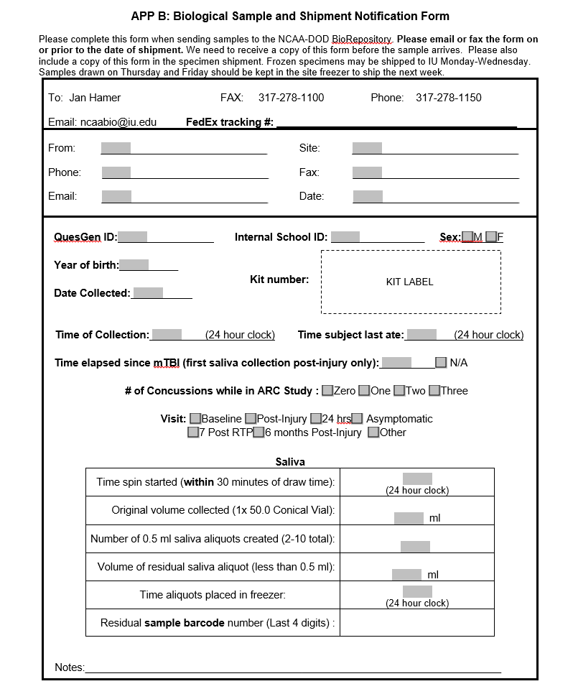
Appendix 1: Biological Sample and Shipment Notification Form (CARE Consortium example)

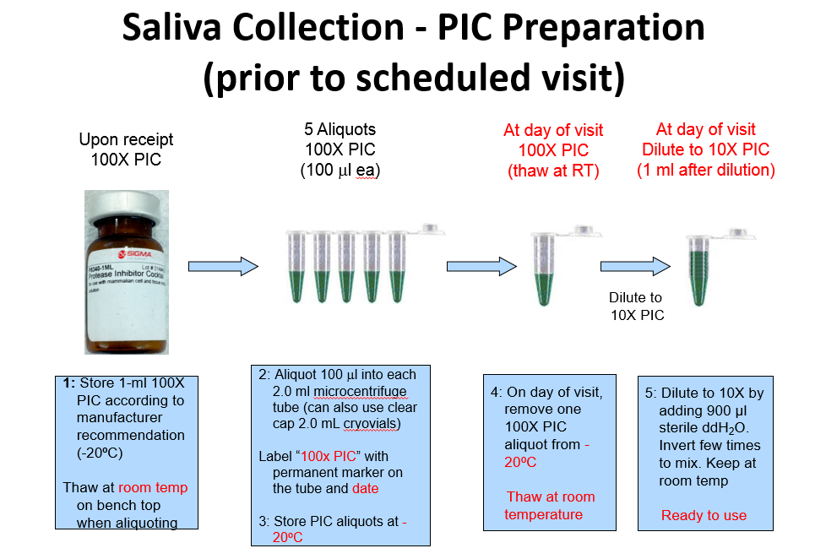
Appendix 2: 10x PIC Preparation Schematic

Appendix 3: Saliva Collection and Aliquoting Schematic
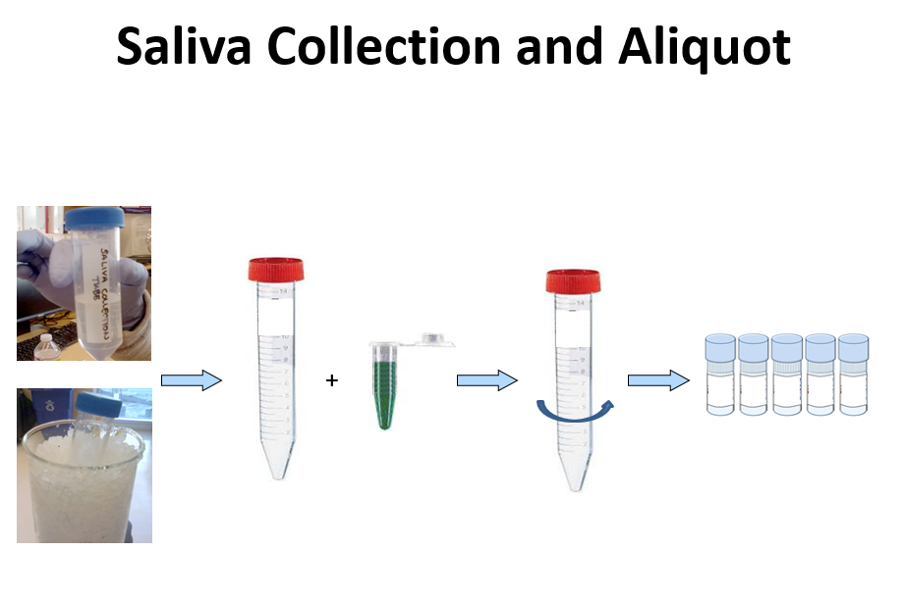

Appendix 4: Summary of Shipping Information
Dry Ice | Category B infectious Substance | Shipment Type
Dry Ice  or  Carbon Dioxide, solid | Diagnostic specimens or  Clinical specimens | Proper Shipping Name
UN 1845 | UN 3373 | UN Number
9 | 6.2 | Hazard Class
III | - | Packing Group (PG)
904 | 650 | Packing Instruction (PI)
200 kg | 4 L or 4 kg | Max. Net qty./pkg. for Passenger Aircraft
200 kg | 4 L or 4 kg | Max. Net qty./pkg/ for Cargo Aircraft

Appendix 5 SHIPPING LABELS (EXAMPLE)

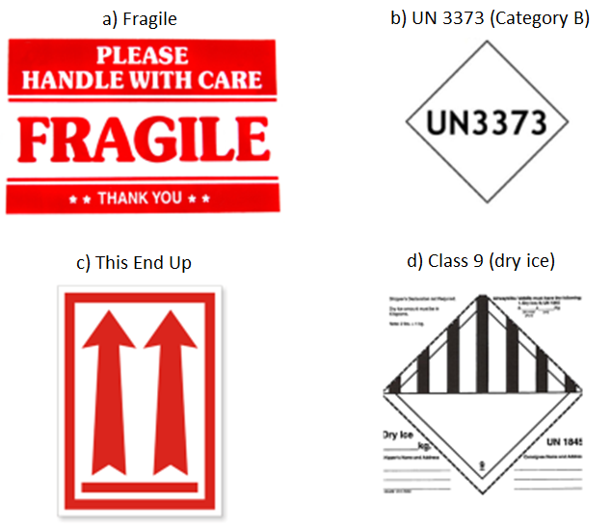
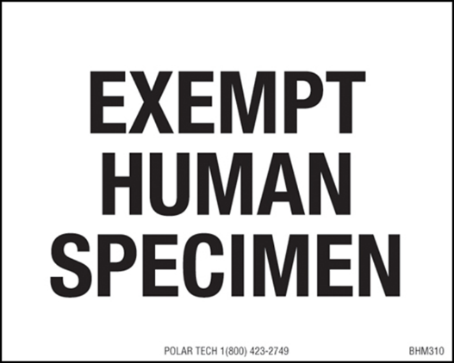
b) Exempt Human Specimen

Appendix 6 SPECIMEN LABELS (SUMMARY & EXAMPLE)
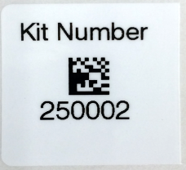
  - Kit Label
    - Number assigned to all patient samples for one visit.
    - Included on the Biological Sample and Shipment Notification Form, the CRF and the lid of the cryobox.

  - Subject ID Label
    - ID assigned to the subject that connects visits from one patient.
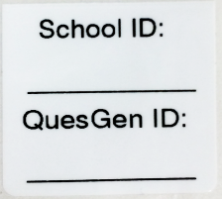
    - Subject ID is typically handwritten onsite using Bio-Pen and should be included on each Biological Sample and Shipment Notification Form and CRF.
    - In the example on the right, two Subject ID’s are provided. One unique to the site and one unique to the subject.
    - Placed on collection tubes only and not cryovials that will be distributed to other laboratories.

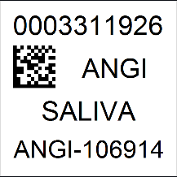
  - Collection Tube/Cryovial Labels
    - Each individual Collection tube and cryovial should be assigned a unique barcode number.
    - Each label should also include the Study Abbreviation, Sample Type, and Kit Number.

