GENERAL INFORMATION

OBJECTIVE
This document describes the requirements for the collection and shipment of saliva samples from research sites to a central storage site. Adherence to this protocol will ensure that all samples are stable and accounted for during the collection and transport process.

SCOPE
This protocol applies to all active saliva samples collected during the course of the study as well as all staff responsible for collecting, recording, and shipping such samples.

RESPONSIBILITIES
- All personnel involved in specimen handling will be trained and certified on the United States and International laws governing the handling and transport of blood-borne, bio-hazardous materials through their site’s recognized local agency(s).
- The Principal Investigator (PI) at each research site is responsible to ensure the proper handling of study samples.
- Each research site is responsible for organizing and documenting sample shipments to the central processing and storage facility.
- The central processing and storage facility is responsible for receiving and documenting sample shipments, storing samples from all centers, and transferring samples to other laboratories as requested.

ATTACHMENTS
  - Appendix 1: Biological Sample and Shipment Notification Form (IUGB Example)
  - Appendix 2: Saliva Collection and Aliquoting Schematic
  - Appendix 3: Exempt Human Specimen Shipping Label

SUPPLIES

SITE REQUIRED EQUIPMENT
The following materials and equipment are necessary for the collection of specimens:
      - Personal Protective Equipment: lab coat, nitrile/latex gloves, and safety glasses
      - Biohazard bin and lid
      - Wire Rack

SPECIMEN COLLECTION & STORAGE SUPPLIES
- Plastic biohazard bag with absorbent sheet
- 1 x Saliva Kit with Labeled tube
- Labels: Collection Tube Label
- Labels: Subject and Site ID Label
- Padded envelope with Central Storage Facility address label
- Bio-Pen for labeling the collection tube label

PACKAGING SUPPLIES
- PRIMARY RECEPTACLE: Saliva Collection Tube holding sample
- SECONDARY RECEPTACLE: Leak-proof, biohazard-labeled plastic bag, capable of withstanding pressures to 95kPa during transport with absorbent sheet
  - OUTER SHIPPING PACKAGE: Padded Envelope with Central Storage Facility address label
        - Correct central storage facility’s address must be in the recipient area of outer packaging
  - CENTRAL FACILITY PROCESSING FORM: Place in separate plastic bag and include in shipment
  - SHIPPING LABELS: Required to communicate the contents of the package to the courier
        - Exempt Human Specimen

BIOSPECIMEN COLLECTION

GENERAL Collection INFORMATION

See Appendix 2 for Saliva Collection Instructions with Graphics

- Prepare kit prior to sample collection and follow Universal Precautions at all times.
- Saliva tube and Biological Sample and Shipment Form should be labeled prior to collecting specimen.
  - Using a BioPen, write proper Site ID and Patient ID on subject label.
  - Label with Collection Tube label AND Subject ID label.
  - See Appendix 4 for examples of all labels.
- Track the patient closely and obtain the saliva as soon as possible (within 24 hours of injury for acute sample).
- Prepare subject for collection.
  - Instruct subject to fast for at least 30 minutes before collection. Subject should also not smoke or chew gum 30 minutes prior to sample collection.
  - Instruct subject to relax and rub cheeks gently for 30 seconds to generate saliva.
  - Hand subject collection tube. Do NOT remove plastic film/allow subject to remove plastic film from the lid of the collection container.
  - Subject should spit until the amount of liquid saliva reaches the fill line on the collection container. Liquid Saliva must pass the fill line, not the bubbles found above liquid saliva. Do NOT fill above the line.
    - Most subjects will take between 2 and 5 minutes to deliver saliva sample.
  - Once saliva reaches the fill line, hold the tube upright with one hand.
  - Close the lid with the other hand and firmly push until a loud click is heard
  - Liquid in the lid will be released and mix with the sample. Ensure lid is closed tightly.
  - Hold tube upright and unscrew the tube from the funnel. Discard or recycle funnel.
  - Pick up small cap for the tube and close the tube tightly.
  - Shake capped tube for 5 seconds.
  - Seal sample in specimen bag for shipment to central storage facility.
  - Fill out appropriate fields of Biological Sample and Shipment Form (Appendix 1).
    - Ensure matching Specimen labels are on the tube and Sample and Shipment Form.

- BIOSPECIMEN PACKAGING AND SHIPPING INSTRUCTIONS

GENERALShipping INFORMATION
As a shipment is readied, ensure all the following conditions have been met:
  - The packaging and shipping materials are at hand and have been prepared.
  - A courier has been secured/located for mail pickup.

PACKAGING AND LABELING GUIDELINES
      - The primary receptacle (collection tube) must be leak proof.
      - The secondary receptacle (biohazard bag) must be leak proof, and an absorbent sheet must be present.
      - A manifest of specimens being shipped must be included between the secondary container and outer packaging.
      - The outer packaging must display the following labels:
        - Sender’s name and address
        - Recipient’s name and address
        - Exempt Human Specimen label

This link describes the differences between categories A, B, and Exempt substances: https://www.ups.com/content/us/en/resources/ship/hazardous/biological_substances.html

PACKAGING AND SHIPPING INSTRUCTIONS
- Notify Intended Recipient of shipment, including a copy of each Biological Sample and Shipment Form (Appendix 1).
- Ensure Biological Sample and Shipment Form is included in the padded envelope.
- Place specimen bag, with saliva tube sealed inside, into the padded shipping envelope.
- Seal padded shipping envelope.
- Check to ensure your return address has been included on the envelope.
- Send the envelope via U.S. Mail. The envelope may be placed in your mailbox with any outgoing mail or mailed through any USPS drop box or post office location.
ATTACHMENTS
Appendix 1: Biological Sample and Shipment Notification Form (IUGB Example) 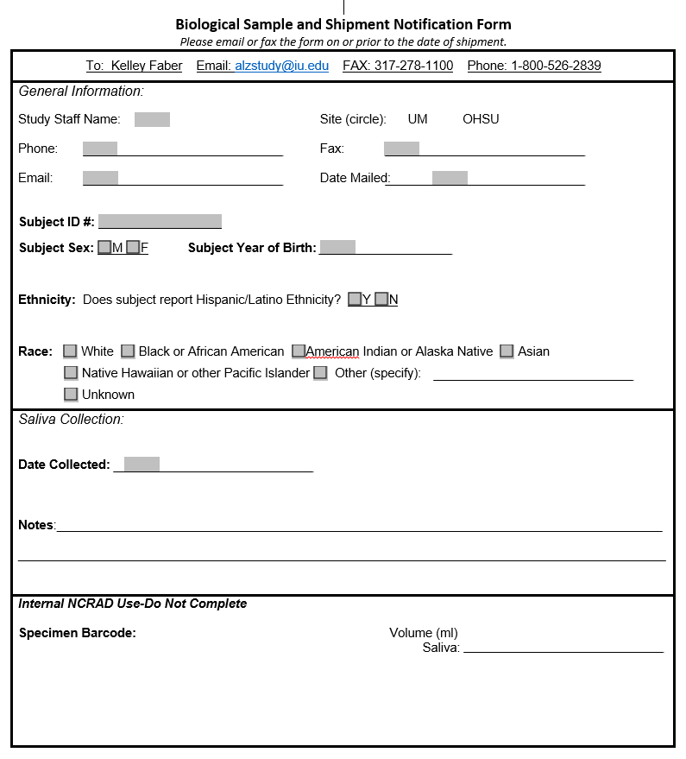

Appendix 2: Saliva Collection Instructions
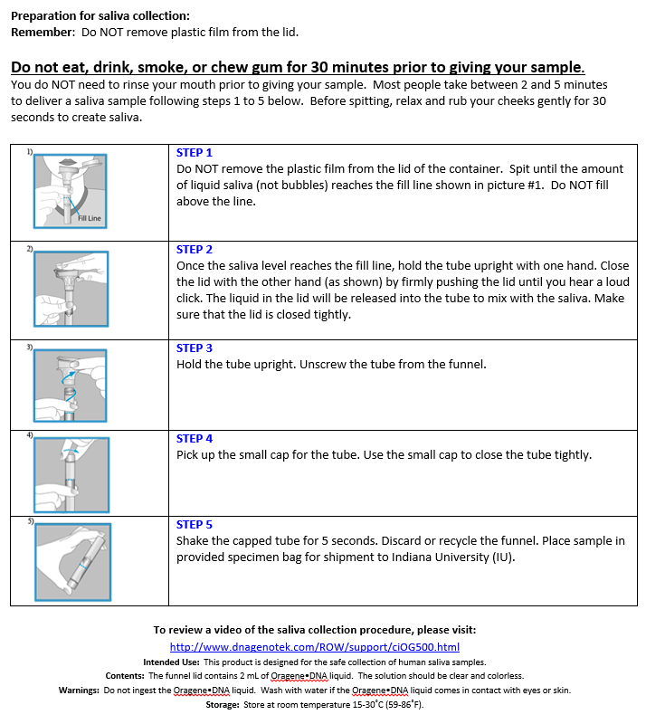

Appendix 3 EXEMPT HUMAN SPECIMEN SHIPPING LABEL

Appendix 4 SPECIMEN LABELS (SUMMARY & EXAMPLE)

  - Subject ID Label
    - ID assigned to the subject that connects visits from one patient.
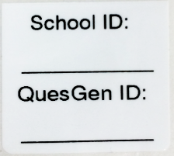
    - Subject ID is typically handwritten onsite using Bio-Pen and should be included on each Biological Sample and Shipment Notification Form and CRF.
    - In the example on the right, two Subject ID’s are provided. One unique to the site and one unique to the subject.
    - Placed on collection tubes only and not cryovials that will be distributed to other laboratories.

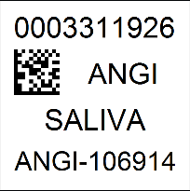
  - Collection Tube/Cryovial Labels
    - Each individual Collection tube should be assigned a unique barcode number.
    - Each label should also include the Study Abbreviation, Sample Type, and Kit Number.

