Date Injury Occurred (mm/dd/yyyy):

Time of Injury (24 hour clock):

Day of week of injury:
Monday Tuesday Wednesday Thursday Friday Saturday Sunday

Source of information: Clinician
Player Parent Coach Other

Reliability of injury data: Verified Estimated Unknown

- Who was the clinical assessment completed by?
Athletic Trainer Coach Physicians Assistant
Medical Doctor Physical Therapist Other

- How confident was clinician that injury was a concussion?
Not at all Confident Barely Confident Somewhat Confident
Fairly Confident Very Confident

- If injury data is ESTIMATED, injury data type (point in time):
Time participant became symptomatic
Time of first trauma activation
Time of presentation to emergency dept

- How many hours after the injury did the first evaluation take place?

- How many hours after the injury did the second evaluation take place?

- How many hours after the injury did the third evaluation take place?

- Does subject have a baseline? Yes No

- Was athlete taken out of game? Yes No

- Did the athlete immediately report the injury? Yes No
  - If no, how many minutes/hours after injury did athlete report it to someone?

- Did athlete continue participation after suspected injury event? Yes No
  - If so, for how long?
  - For how many plays?

- Did athlete go to ER? Yes No

- Treated at hospital before study center? Yes No

- Date treated at hospital: mm/dd/yyyy

- Time treated at hospital: 24 hour clock

- Hospital admission date:
NA

- Hospital admission time (mm/dd/yyyy; 24 hour clock):

- Symptom onset date: mm/dd/yyyy

- Symptom onset time: 24 hr clock

- Were initial medical services received immediately after injury? Yes No Unknown

- Medical Services received:
CT/MRI
Hospitalization
Specialized therapies
Evaluation (neuro, psych)
Medications
Education on symptoms or course of injury
Other, specify:

- At the time of injury, was any protective equipment worn? Helmet, mouthguard, tape, brace, other

- Sport at time of injury

- Position at time of injury

- Injury occurred during: Game, practice, dryland/fitness, other

- Injury involved: Sudden onset and contact with another player; sudden onset and no contact with another player; Gradual onset/overuse; unknown

- Cause of injury (will depend on sport) – body check, tackle, intentional player contact (elbowing, roughing, cross-check, dueling for header, etc)

- Mechanism of injury: direct blow to head, fell and hit head, hit head on environment, non head injury

- Was a penalty called directly related to the injury event: Yes/no if yes, describe; who received penalty

- Describe events surrounding the injury:

- Injury location for each type of injury (often more than one injury at time of injury- list of all injury types and body parts)

- Mechanism of Injury: Contact with another player Impact with ground Impact with object (i.e. ball)

- Likelihood participant under influence of alcohol:
None Suspected Confirmed Unknown

- Location of impact:

Frontal
L temporal
R temporal
L parietal
R parietal
Occipital
Neck
Indirect force

- Injury Description:

SYMPTOMS
- Loss of consciousness Yes No
  - Duration: < 1 min 1-30 min 30 - 24 hr

- Dizziness Yes No
  - Duration: 0-1hr 1-24hr >24hr

- Retrograde amnesia Yes No
  - Duration: 0-1hr 1-24hr >24hr

- Amnesia of event Yes No
  - Duration: 0-1hr 1-24hr >24hr

- Post traumatic amnesia Yes No
  - Duration: 0-1hr 1-24hr >24hr

- Confusion/disorientation Yes No

- How long did symptoms last after injury/impact? days, hours, minutes

- Symptoms:
Dizziness
Off-balance
Fogginess/ confusion
Nausea/vomiting
Memory loss
Vision changes
Headache

- Baseline headache impact test-6 (HIT-6)

- Follow-up headache impact test-6 (HIT-6)

- Brain imaging abnormality: Yes No No imaging
  - Type of imaging:

- Pain Assessment :

Faces Rating Scale (Wong Baker):
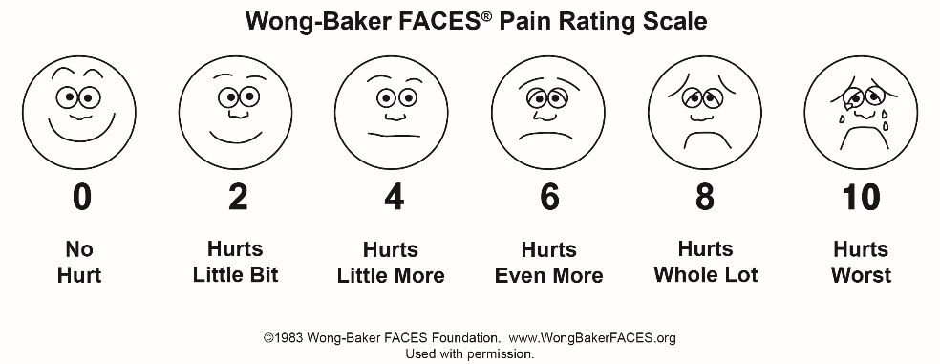

Explanation:
- For use with ages 4 and older
- Explain to the child that each face is for a person who feels happy because he has no pain (hurt), or sad because he has some or a lot of pain

Face 0 is very happy because he doesn’t hurt at all.
Face 2 hurts just a little bit
Face 4 hurts a little more
Face 6 hurts even more
Face 10 hurts as much as you can imagine

Ask the child to choose the face that best describes how he/she is feeling.
0=no pain 1–3=mild pain 4=moderate pain 7–10=severe pain

0–10 Numeric Pain Rating Scale:
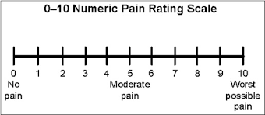

Explanation:
- For use with ages 8 and older
- Explain to the child that at one end of the line is 0, which means that a person feels no pain (hurt). At the other end is a 10, which means the person feels the worst pain imaginable. The numbers 1 to 9 are for a very little pain to a whole lot. Ask the child to choose the number that best describes how he/she is feeling.

0=no pain 1–3=mild pain 4=moderate pain 7–10=severe pain

Visual Analog Scale (0-10) – Mark ’X’ to area on the line with 0 being no pain to 10 being the worst pain.

0 ________________________________________________________ 10

- Suicidal Ideation

ORTHOPEDIC INJURIES
- Did/Does Athlete Have any Other Orthopedic Injuries? Yes No
  - Head (Non-Concussive) Yes No
  - Neck Yes No Sore but not injured
  - Shoulder Yes No
  - Arm/Elbow Yes No
  - Wrist/Hand/Fingers Yes No
  - Back Yes No
  - Trunk Yes No
  - Hip/Thigh Yes No
  - Knee Yes No
  - Lower Leg/Foot/Toe Yes No

REPEAT INJURY

- Repeat concussion this year

POST-INJURY STATUS
- Return to work/school:
Returned to previous level
Same work or school, reduced level
Different work or school
Only in sheltered environment
Did not return to work or school
N/A
Unknown

- Injury ICD external cause code:

OTHER INFORMATION
- Approximately how many days of school has the child missed?
0 1-2 days 3-6 days 7+ days

- Please indicate the grade that your child is currently enrolled in:

Kindergarten
Grade 1
Grade 2
Grade 3
Grade 4
Grade 5
Grade 6
Grade 7
Grade 8
Grade 9
Grade 10
Grade 11
Grade 12
Not currently enrolled
Other, Specify:

- Please indicate your child's average academic achievement prior to the concussion:
Straight A student
A & B grades
Straight B student
B & C grades
Below C grades

- Has your child had a CT or MRI for a PREVIOUS head injury? Yes No Unknown

- Has your child been hospitalized for a previous head injury? Yes No Unknown

- Has your child received any medication since the time of their injury? Yes No
  - Specify which medication(s) your child received since the time of their injury. Check all that apply:
Acetaminophen (Tylenol, Tempra)
Ibuprophen (Advil, Motrin)
Gravol
Other, Specify:

- After your child's head injury did he/she have a seizure? Yes No

- Current academic year in which your child will be participating in enrolled sport:

6th grade
7th grade
8th Grade
HS-Fr
HS-So
HS-Jr
HS-Sr
College-Fr
College-So
College-Jr
College-Sr
College-5th Yr
College-6th Yr

(i.e. baseline test in spring or summer for fb, academic year is what they will be when participating in sport in fall)

- Does your child have a history of Special Education? For example, have you had any special classes or accommodations in school? No Yes Unknown

- Have you ever had an IEP (Individualized Education Program) or extra support for studies? No Yes Unknown
  - If yes, what did you have an IEP in? Reading Writing Math Other

- What type of student were/are you in high school?
Below Average
Average
Above Average

General Instructions
Important note: None of the data elements on this CRF Module are considered Core (i.e., strongly recommended for all sports-related concussion clinical studies to collect). They are supplemental and should only be collected if the research team considers them appropriate for their study.

Specific Instructions
Please see the Data Dictionary for definitions for each of the data elements included in this CRF Module.

