Speech and Language Therapy Treatment Session: Cerebral Palsy 0–18 years
General Information | Session Information | Complete at End of Individual Session
Patient/Client Name or ID # | Session Type: ☐ Individual ☐ Group ☐ Co-Tx  Setting: ☐ Home-based ☐ Day Care ☐ School-based  ☐ Early Intervention ☐ Day Tx Program ☐ Residential Facility  ☐ Inpatient (acute med)☐ Inpatient (acute rehab)  ☐ Inpatient (subacute rehab) ☐ Outpatient Clinic ☐ Other | Session Duration (total time in minutes):  Total Units of service billed (if any):
Date:  SLP: |  | Child Effort: 0----—1—----2—----3—----4—----5-------6 (see p.2)
Pain yes no If yes, list pain level number ____
circle which pain scale: Faces FLACC Number (See p. 2)
CFCS Level (circle) I II III IV V
CFCS Communication Methods Used: | Session participants: ___ # patients ___ # therapists | Factors influencing session:  □ agitation/behavior □ disinterest □ fatigue □ low arousal  □ inattention □ emotional distress/crying □ medical  □ environment
__Speech __Sounds __Manual signs  __Eye gaze, facial expression, gesture, point  __Communication Book, Pictures ___SGD | ____ # family/caregiver ____ # other ___________  Frequency: ___ per week ____ per month  ____ consultative (˂ 1 x month)

SLP Focus Areas | Mins | Intervention #
Speech Production
Language, Receptive (Understanding)
Language, Expressive (Producing)
Language, Social (Pragmatics)
Swallowing/Dysphagia/Oral Feeding
Cognitive/Developmental Skills
Augmentative & Alternative Communication (AAC)
Environmental Factors
Assessments
Home
Leisure/Community
Education/School
Social participation
Vocation/Job

Intervention # | Intervention # | Intervention #
Speech | Language, Receptive | Language, Expressive
1. Breath Coordination | 31. Following 1-Step Commands | 63. Naming/Object ID/Labeling
2. Speech Intelligibility Strategies | 32. Following Multi-Step Command | 64. Gesture Use/Demo Obj. Function
3. Speech Sound Production | 33. Word Matching | 65. Describe Picture/Object Function
4. Vocal Function Exercises | 34. Yes/No Questions | 66. Morphology/Syntax
5. Speaking Valve | 35. Wh- Questions | 67. Phrase Production
Language, Social (Pragmatics) | 36. Sentence Comprehension | 68. Defining Words
6. Conversation | 37. Paragraph Comprehension | 69. Compound/Complex Sentence
7. Turn-Taking | 38. Morphology/Syntax | 70. Asking/Answering Questions
8. Establishing Joint Attention | 39. Sequencing | 71. Multi-Sentence Production
9. Initiation | 40. Categorization | 72. Conversation level
10. Topic Maintenance/Change | 41. Object Identification | Community Access
Cognitive/Developmental | 42. Picture Discrimination | 73. Simple Functional Tasks
11. Cause/Effect | 43. Picture Identification | 74. Identify signs in community
12. Object Permanence | 44. Object Function | 75. Developing Daily Schedule
13. Functional Play | Swallowing/Dysphagia | 76. Complex Functional Tasks
14. Play Skills | 45. Pre-Swallowing (Oral Hygiene) | 77. Community Outings
Problem Solving/Reasoning | 46. Meal Observation Analysis | Memory/Orientation
15. Environmental Problem Solving | 47. Oral Stim/Desensitization | 78. Delayed Recall
16. Paper/Pencil Problem Solving | 48. P.O. Trials | 79. Immediate Recall
17. Sequencing | 49. Swallow Strengthen Exercise | 80. Compensation- Ext Strategy
18. Verbal Reasoning | 50. Oral Motor Swallow Exercises | 81. Compensation-Internal Strategy
19. Functional Problem Solving | 51. Swallow Strategies/Maneuvers | 82. Spaced Retrieval
Attention | Aug & Alt Com (AAC) | 83. Working Memory
20. Visual Scanning | 52. Multi-Modal Communication | 84. Verbal Orientation Review
21. Visual Attention | 53. High-Tech Com Device | Other Activities
22. Auditory Attention | 54. Low-Tech Com Device | 85. Sensory Stimulation
Assessments/Screening | 55. Operational Competency | 86. Games
23. Cognition Assessment | 56. Strategic Competency | 87. Switch Toys
24. Language Assessment | 57. Pictures/PECS | 88. Switch Training Activities
25. Speech Assessment | 58. Manual Signs | 89. Computer App (Office/Email/Web)
26. AAC Assessment | Environmental Factors | 90. Specialized Software
27. Swallowing Assessment- Bedside | 59. Patient Education | Literacy
28. Swallowing Assessment- FEES | 60. Caregiver/Parent Education | 91. Reading
29. Swallowing Assessment- MBSP | 61. Com Partner Training | 92. Writing
30. Hearing Screening | 62. Assistive Technology Training

Specific Instructions
This form was designed to be inclusive of the possible activities and interventions that SLPs could use. We are not suggesting, however, that a clinician should address all of these focus areas or use all of these interventions.

Please see the Data Dictionary for definitions for each of the data elements included in this CRF Module.
Important note: None of the data elements included on this CRF are considered Core (i.e., strongly recommended for all studies to collect). These data elements are supplemental and should be collected on clinical trials and only if the research team considers them appropriate for their study.

Focus Area: Select each appropriate focus area and record the time spent on each area with the child in 5-minute increments. Please indicate the approximate time spent in each focus area and for each round the time into 5 minute increments. To determine the focus area, you will need to identify the primary intent of each activity. If the primary emphasis is on two focus areas, then split the time between the two areas.

Interventions: Then move to the list of Interventions to the right (numbered 01–92). Select all interventions that were performed to achieve the purpose of each selected focus area and write the code numbers of the interventions used within the boxes provided.

CFCS Level and Communication Methods Used refer to the Communication Function Classification System which can be downloaded at www.cfcs.us

Child Effort Rating (adapted from Westcott-McCoy and Linn 2010, Horn 2015): record an overall rating for “Child Effort” across the entire session by circling a number on the visual analogue scale: 0 = child’s behavior during the session(s) was not at all conducive to achieving the service objectives, to 6 = child’s behavior during the session(s) was exceptionally conducive to achieving the service objectives Choose the number that best fits your initial impression.
0= absence of effort
4=above average effort
5=very good effort
6=superior effort
1= minimal effort
2=below average effort
3=Average effort
This scale should reflect the normal distribution of the population, which means that a score of 0 or 6 is uncommon. Most people tend to fall into the categories of 2, 3, and 4 where 3 would be average effort. This is not a measure of the patient’s ability! Choose the number that best fits what you observed the patient DO- not whether s/he did his/her “best”. (Horn 2015)

This form is adapted from:
Effgen, S., Westcott McCoy, S., Chiarello, L., Jeffries, L., & Bush, H. (2016). Physical therapy–related child outcomes in school: An example of practice-based evidence methodology. Pediatr Phys Ther. 28(1):47–56.
Horn SD, Corrigan JD, Bogner J, Hammond FM, Seel RT, Smout RJ, Barrett RS, Dijkers MP, Whiteneck GG. Traumatic Brain Injury-Practice Based Evidence Study: Design and Patients, Centers, Treatments, and Outcomes. Arch Phys Med Rehabil. 2015;96(8 Suppl):S178–S196.e15.
McCoy SW , Linn M 2010 Training Manual School - Physical Therapy Interventions for Pediatrics (S-PTIP) Data Form version 4.
FLACC Scale (Extracted from The FLACC: A behavioral scale for scoring postoperative pain in young children, by S Merkel and others. 1997. Pediatr Nurse. 23(3): 293–297).
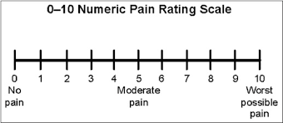
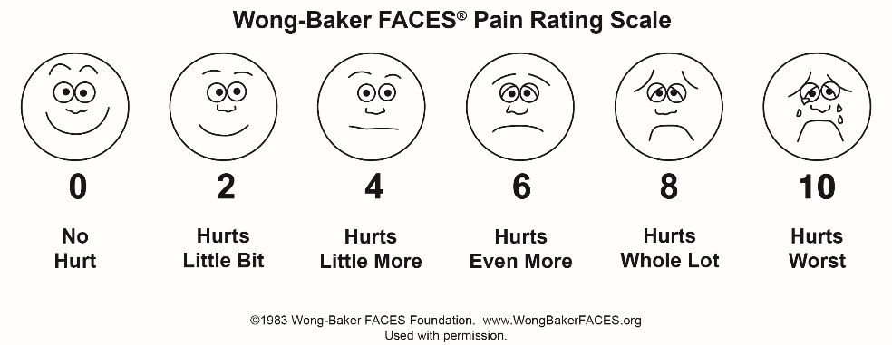

Face, Legs, Activity, Cry, Consolability scale or FLACC scale is a measurement used to assess pain for children between the ages of 2 months and 7 years or individuals that are unable to communicate their pain. The scale is scored in a range of 0–10 with 0 representing no pain.
Criteria | Score 0 | Score 1 | Score 2
Face | No particular expression or smile | Occasional grimace or frown, withdrawn, uninterested | Frequent to constant quivering chin, clenched jaw
Legs | Normal position or relaxed | Uneasy, restless, tense | Kicking, or legs drawn up
Activity | Lying quietly, normal position, moves easily | Squirming, shifting, back and forth, tense | Arched, rigid or jerking
Cry | No cry (awake or asleep) | Moans or whimpers; occasional complaint | Crying steadily, screams or sobs, frequent complaints
Consolability | Content, relaxed | Reassured by occasional touching, hugging or being talked to, distractible | Difficult to console or comfort

